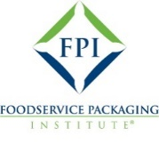
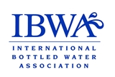
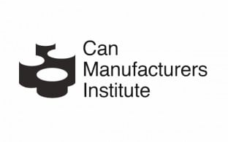
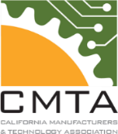
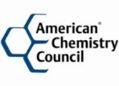
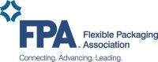
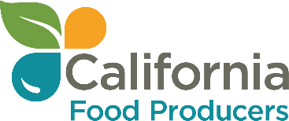
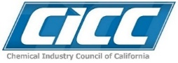




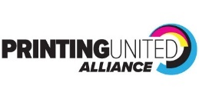



June 25, 2025

The Honorable Catherine Blakespear, Chair
Senate Environmental Quality Committee
1021 O Street, Suite 3230
Sacramento, CA 95814

RE: AB 1148 (Sharp-Collins): Food packaging; hazardous chemicals
As amended June 17, 2025 – OPPOSE UNLESS AMENDED
Set for Hearing, July 2, 2025

Dear Senator Blakespear:

The American Chemistry Council (ACC) and the undersigned organizations have taken an “Oppose Unless Amended” position on AB 1148 (Sharp-Collins), legislation that would ban food packaging that contains any intentionally added bisphenols or phthalates beginning January 1, 2027.

Product and process safety is our top priority, and we support appropriate regulatory oversight of ingredients and materials used in packaging that is grounded in sound science and includes a rigorous discussion among stakeholders of the available scientific information and data.

The coalition believes the regulatory framework and authority that rests with the California Department of Toxic Substances Control (DTSC) and the United States Food & Drug Administration (FDA) provide the appropriate forum to assess the safety of food packaging materials, establish appropriate threshold levels for intentionally added ingredients, and if necessary, impose any regulatory requirements. As outlined below DTSC has broad authority under the Safer Consumer Products (SCP) program to identify chemical/product combinations and, if warranted, impose use restrictions, including “Restrictions on the amount or concentration of the Chemical(s) of Concern or replacement Candidate Chemical(s) permitted in a product.”

Though DTSC has not decided to identify these specific chemistries in food packaging applications as a priority product, the coalition is strongly opposed to legislation that would ban specific chemicals in products without the benefit of an open, transparent and science-based process under the auspices of the appropriate regulatory agency. To that end, the coalition has offered the attached amendments to ensure such criteria are met. In summary, the proposed amendments would:

- Require DTSC by 1/1/30 to evaluate the use of bisphenols and phthalates in food packaging applications to determine whether it is necessary to establish a minimum safety threshold level.
- If DTSC determines a regulation is necessary, require the department to initiate a formal rulemaking process that establishes such levels by 1/1/32.
- Provide manufacturers and retailers with a 24-month “sell thru” period for existing stocks of food packaging.
- Modifies covered products to exclude reusable containers, those used in commercial or industrial settings, or packaging for dietary supplements.

Additional DTSC Authority under the SCP Program
California Code of Regulations, title 22, section 69501.4(b) authorizes DTSC to request information from product or chemical manufacturers, importers, assemblers, or retailers that it determines necessary to implement the SCP’s framework regulations, via an information call-in. DTSC may use the information obtained through call-ins for several purposes, including identifying product-chemical combinations to evaluate as potential priority products; identifying and analyzing alternatives to eliminate or reduce potential exposures and adverse impacts; and filling data gaps to improve understanding and reduce research time.

The 2022/23 budget provided DTSC with additional funding to hire more staff to fully implement the SCP program. The budget change proposal stated, “…the Department of Toxic Substances Control (DTSC) requests 37.0 permanent positions and $7.2 million Toxic Substances Control Account (TSCA) in 2022-23 and ongoing to provide the resources needed to fully implement the Safer Consumer Products (SCP) Program.”

In 2022, the Legislature passed SB 502 (Allen) that expanded DTSC’s authority to require manufacturers to provide specific information including:

- information on ingredient chemical identity, concentration, and functional use;
- existing information, if any, related to the use of the products by children, pregnant women, or other sensitive populations; and
- data on state product sales, or national product sales in the absence of state product sales data.

SB 502 also gave new authority to DTSC to move directly to a regulatory response instead of requiring manufacturers to conduct an alternative analysis. The Assembly Environmental Safety and Toxic Materials Committee analysis (June 14, 2022) included a comment from the bill’s author that stated, “the adjustments made by SB 502 will ensure DTSC has the tools they need to efficiently identify and address unsafe chemical ingredients in everyday products." DTSC just this month initiated rulemaking to implement the provisions of SB 502.

DTSC and Food Packaging
DTSC has been active in considering chemistries used in food packaging applications, specifically including “food contact articles” in its most recent SCP three-year workplan. DTSC notes that as part of its stakeholder engagement process “we revised and expanded this category to include all products that are (1) intended to be used with food and (2) come in contact with a food product at any stage of its life cycle, including processing, packaging, preparation, cooking, serving, and transportation. This definition is more broad than the U.S. Food and Drug Administration’s (FDA’s) definition of food contact substances as it includes products in contact with food at any stage of a food product’s life cycle and applies to the entire product.” (emphasis added)

Finally, the SCP provides a process for anyone to petition DTSC to add to or remove from the Priority Products list a product-chemical combination. In fact, the SCP regulations require DTSC to “give high priority to reviewing petitions by federal and other California State agencies that relate to the petitioning agency's statutory and/or regulatory authorities.”

In 2017, DTSC denied a public petition that would have designated food cans with BPA resin linings as a priority product. The department determined that “the original petition and the supplemental information submitted on March 14, 2017, did not provide sufficient detail to enable DTSC to rigorously evaluate BPA in food can linings.”

Should your committee move AB 1148 forward, we respectfully request your consideration of the proposed amendments put forth by the coalition. Thank you in advance for considering our comments.

Sincerely,


Tim Shestek
American Chemistry Council

On behalf of the following organizations:

Mike Smaha, Can Manufacturers Institute
James Toner, International Bottled Water Association
Katie Little, California Food Producers
Carol Patterson, Foodservice Packaging Institute
Meredith Fossett, Vinyl Institute
Elizabeth Esquivel, California Manufacturers & Technology Association
John J. Richard, Flexible Packaging Association
Edwin Borbon, American Institute for Packaging and the Environment (AMERIPEN)
Adam Regele, California Chamber of Commerce
Lisa Johnson, Chemical Industry Council of California
Erin Raden, Consumer Brands Association
Gary Jones, Printing United Alliance
George R. Fuchs, National Association of Printing Ink Manufacturers

ATTACHMENT – Coalition amendment mock-up (6/22/25)

cc: Members, Senate Environmental Quality Committee
The Honorable Dr. LaShae Sharp-Collings, Member of the Assembly
Mr. Michael Lucien, Chief of Staff, Office of Assembly Member Sharp-Collins

§ 69506.4. Use Restrictions on Chemicals and Consumer Products.
https://bcp.dof.ca.gov/2223/FY2223_ORG3960_BCP5200.pdf
https://leginfo.legislature.ca.gov/faces/billAnalysisClient.xhtml?bill_id=202120220SB502#
https://calsafer.dtsc.ca.gov/cms/commentpackage/?rid=12784
https://dtsc.ca.gov/wp-content/uploads/sites/31/2024/10/2024-2026-Priority-Product-Work-Plan.pdf
§ 69504.1. Merits Review of Petitions

